MAD Project Proposal

# Submitted to:

* Mam Hina Khalid

# Submitted by:

* 2016-CS-122
* 2016-CS-178

# Department of Computer Science and Engineering

# UET Lahore

**Date:** 27-Oct-2019



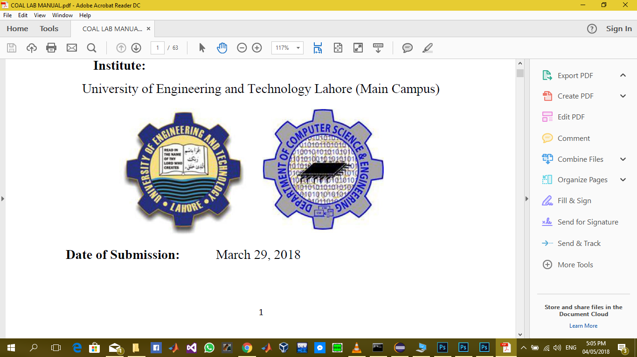

# Synopsis:

We are going to build a robot information app with a module which will control a robot with Bluetooth and a camera will be used to get live streaming that camera will be attached to that robot. Its like a robot dictionary where you can find types of different robots and we can also add more robots in the collection and when user clicks on one robot in list, they can view all the details related to that certain robot.

The robot we will be controlling in this application is a remote-control tank but after a few modifications and addition of sensors will make it usable for this android application.

# Requirements:

* User will be needing a robot to use the control and sensor module of camera.
* A database to save all the information of robots.
* Multiple screens to show different types of robots and to add them in database.
* A web service protocol to live stream the camera on robot with app.
* Menus to display robots.
* Popup menu to add new robot in list.

# Use Cases:

**1.1 Use Case UC1: Drive robot with Bluetooth**

* Stakeholders: Students, person interested in robotics.
* Primary Actors: Students, person interested in robotics.
* Post Condition:

Robot can be drive by up down left right button on screen of app.

* Main Success Scenario:
  + User starts app.
  + A successful Bluetooth connection is established.
  + Robot is connected with Bluetooth.
  + Robot can be controlled and drive with Bluetooth.

**1.2 Use Case UC2: Get temperature data with Bluetooth**

* Stakeholders: Students, person interested in robotics.
* Primary Actors: Students, person interested in robotics.
* Post Condition:

Temperature data of the surroundings can be recorded by bluetooth.

* Main Success Scenario:
  + User starts app.
  + A successful Bluetooth connection is established.
  + Bluetooth will be connected to a temperature sensor.
  + The data of temperature sensor attached with robot can be sent to app.
  + App records the temperature and shows it successfully.

**1.3 Use Case UC3: Get live video by WIFI**

* Stakeholders: Students, person interested in robotics.
* Primary Actors: Students, person interested in robotics.
* Post Condition:

Camera can be live streamed on app with the help of wifi.

* Main Success Scenario:
  + User starts app.
  + A successful Wifi connection with IP camera is established.
  + IP camera is attached with robot.
  + App can show the live streamed video successfully.

**1.4 Use Case UC4: Control Robot with gyroscope sensor**

* Stakeholders: Students, person interested in robotics.
* Primary Actors: Students, person interested in robotics.
* Post Condition:

Camera can be controlled with gyroscope sensor.

* Main Success Scenario:
  + User starts app.
  + Ip camera is connected with app.
  + Camera can be controlled with gyroscope.

**1.5 Use Case UC5: View all types of robots**

* Stakeholders: Students, person interested in robotics.
* Primary Actors: Students, person interested in robotics.
* Post Condition:

All types of robots can be viewed on a screen.

* Main Success Scenario:
  + User starts app.
  + All types of robots can be shown on screen.

**1.6 Use Case UC6: View Details of each robot**

* Stakeholders: Students, person interested in robotics.
* Primary Actors: Students, person interested in robotics.
* Post Condition:

Details of each robot can be viewed on a single screen.

* Main Success Scenario:
  + User starts app.
  + Types of robots can be viewed.
  + Details of each robot can be seen on a separate screen by simply clicking on it.